
NATIONAL INSTITUTE OF TECHNOLOGY PUDUCHERRY
(An Institution of National Importance under MHRD, Govt. of India)
KARAIKAL – 609 609

DEPARTMENT OF COMPUTER SCIENCE AND ENGINEERING
Roll Number: | CS19B1016 | Name | BOYINA AJAY SANTHOSH
Semester: | II | Class: | B TECH 1ST YEAR
Subject Code: | CS106 | Subject Name: | DATA STRUCTURES LABORATORY

1.1 LINEAR SEARCH
Date:10.11.19

AIM:
To search the element in array by linear search through C program.

ALGORITHM:

1. Start the program.
2. input the array from the user.
3.declare the variable key ( we have to search key element in given array).
4. compare all elements with key by one by one by using for loop.
5. if array[i]=key then print element is found and present in i position.
6. else print element is not found.
7.close the program.

PROGRAM:
#include <stdio.h>
int main()
{
int array[100], search, c, n;

printf("Enter number of elements in array\n");
scanf("%d", &n);

printf("Enter %d integer(s)\n", n);

for (c = 0; c < n; c++)
scanf("%d", &array[c]);

printf("Enter a number to search\n");
scanf("%d", &search);

for (c = 0; c < n; c++)
{
if (array[c] == search) /* If required element is found */
{
printf("%d is present at location %d.\n", search, c+1);
break;
}
}
if (c == n)
printf("%d isn't present in the array.\n", search);

return 0;
}

OUTPUT:
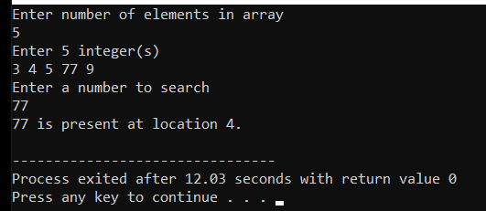

RESULT:

The program is successfully executed.

1.2 BINARY SEARCH

AIM:
To search the element in array by binary search through C program.

ALGORITHM:
1. Start the program.
2.declare the variable key( element we have to search in array).
3. declare the array and input the array from user.
4. compare the key element with middle element in the array.
5. if key is greater than middle element then go to the function from
mid +1 to last index in array.
6. if key is less than middle element then go to the function from zero to mid-1 index in array.
7. if key is equal to the middle element then print element is found and print the position of that element.
8. repeat this process continuesly through recursive functions until
low >high
9.we use this binary search to reduce the time complexity to log(n).
10. close the program.

PROGRAM:

#include <stdio.h>

int binarySearch(int array[], int x, int low, int high)
{
if (high >= low)
{
int mid = low + (high - low) / 2;

if (array[mid] == x)
return mid;

if (array[mid] > x)
return binarySearch(array, x, low, mid - 1);

return binarySearch(array, x, mid + 1, high);
}

return -1;
}

int main( )
{
int array[100],n;
printf("enter n\n");
scanf("%d",&n);
int i,x;
printf("enter array elements\n");
for(i=0;i<n;i++)
{
scanf("%d",&array[i]);
}
printf("enter element u want to search\n");
scanf("%d",&x);
int result = binarySearch(array, x, 0, n - 1);
if (result == -1)
printf("Not found");
else
printf("%d Element is found at index %d",x, result);
}

OUTPUT:

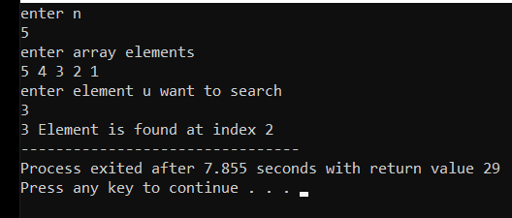

RESULT:

The program is successfully executed.

